

Capstone Project Report
Report 1 – Project Introduction

– HoChiMinh, February 2026–
Table of Contents
I. Record of Changes 3
II. Project Introduction 4
1. Overview 4
1.1 Project Information 4
1.2 Project Team 4
2. Product Background 4
3. Existing Systems 4
3.1 System name1 4
3.2 System name2 4
4. Business Opportunity 4
5. Software Product Vision 5
6. Project Scope & Limitations 5
6.1 Major Features 5
6.2 Limitations & Exclusions 6

I. Record of Changes
Date | A*  M, D | In charge | Change Description
*A - Added M - Modified D - Deleted

II. Project Introduction

1. Overview

1.1 Project Information
- Project name: << Player-Centric Performance Analysis System>>
- Project code: <<SP26SE159>>
- Group name: <<GSP26SE58>>
- Software type: <<Software Type: Web, Mobile App,..>>

1.2 Project Team
Full Name | Role | Email | Mobile
Huynh Tan Trung | Leader
Huynh Minh Phuc | Member
Nguyen Thien Duy | Member
Nguyen Phuc Thien An | Member

2. Product Background
[This section summarizes the rationale for the new product. Provide a general description of the history or situation that leads to the recognition that this product should be built. You should also mention here the information on the customer /the people who raise project idea/request]
<<Football is unequivocally the most popular sport in Vietnam, serving as a major source of entertainment and national pride. The professional football ecosystem, governed by the Vietnam Football Federation (VFF) and VPF, relies on three core pillars: V.League 1, V.League 2, and the National Cup. These tournaments operate on a weekly basis, attracting millions of spectators both in stadiums and through media broadcasts.
However, despite the immense passion from fans and the growing professional quality on the pitch, the digital infrastructure supporting these leagues remains significantly underdeveloped compared to international standards (such as the English Premier League or J-League). The management and consumption of football data in Vietnam currently face three critical challenges:
First, Operational Inefficiency due to Manual Data Entry. Most existing platforms rely heavily on manual processes where administrators must watch matches and hand-type events (goals, cards, substitutions). This leads to data fragmentation, significant latency, and a high risk of human error. There is currently no unified system that utilizes Automated APIs to synchronize real-time match data across V.League 1, V.League 2, and the National Cup simultaneously.
Second, a Lack of Advanced Performance Analytics. Stakeholders—including club managers, scouts, and fans—have limited access to verified, deep analytical data. The market is saturated with basic news sites but lacks comprehensive tools that leverage Computer Vision (AI) technology. Essential modern metrics such as Player Heatmaps, movement trajectory, and distance covered are unavailable, making it difficult to objectively evaluate a player's contribution beyond basic events.
Third, Disconnected Fan Engagement. Fan interaction is currently scattered across various social media pages (Facebook, TikTok) with no official, centralized platform for community activities. Fans lack a dedicated Fandom Ecosystem to formally vote for "Player of the Match," participate in prediction events, or rank players based on verified league data. This results in a passive viewing experience rather than active participation.
Project Motivation: Recognizing these gaps, the "Player-Centric Performance Analysis & Fandom System" project was initiated. The primary goal is to digitize the experience of V.League and the National Cup by replacing manual processes with automated data pipelines, introducing offline AI video analysis for professional-grade insights, and establishing a centralized platform to foster a vibrant, data-driven fan community.
.>>

3. Existing Systems
[Add the system which might help solving the problems you listed above or the systems in which you can learn/refer the features for your system design]
Currently, the landscape of football data consumption in Vietnam is dominated by a mix of international livescore platforms and informal social media channels. While these systems serve basic needs, they fail to provide a specialized, deep-dive experience for the V.League ecosystem. The following analysis highlights the capabilities and limitations of the most prominent existing solutions.

3.1 System 1: Flashscore (Global Livescore Platform)
[Write the brief descriptions of the system, the link, the system actors, features, pros, cons, etc.]
- Brief Description: Flashscore is the world's most popular live score service, providing real-time results and basic statistics for over 6,000 competitions worldwide, including V.League 1, V.League 2, and the Vietnamese National Cup.
- Link: https://www.flashscore.com/football/vietnam/
- System Actors: Football Fans, Sports Bettors, Journalists.
- Features:
  - Real-time match updates (Goals, Cards, Substitutions).
  - League Standings and Fixtures.
  - Basic match statistics (Shots on target, Ball possession, Corners).
  - Push notifications for favorite teams.
- Pros:
- Extremely fast data updates (near real-time).
- Wide coverage of all Vietnamese leagues.
- Reliable availability and uptime.
- Cons:
- Lack of Advanced Analytics: Does not provide deep metrics like Player Heatmaps, Distance Covered, or Trajectory Tracking for V.League matches.
- No Community Engagement: Purely for information consumption; users cannot vote for players or organize community events.
- Generic UI: The interface is standard for all leagues, offering no specialized experience for Vietnamese fans.

3.2 System 2: Social Media Platforms (Facebook Groups/Fanpages)

Brief Description: Social media platforms (specifically Facebook and TikTok) currently serve as the main "unofficial" hub for V.League fan communities. Fans join club Fanpages or general football groups to discuss matches.
- Link: https://www.facebook.com/ (e.g., Hanoi FC Fanpage, Vietnam Football Groups)
- System Actors: Fans, Club Media Admins, Content Creators.
- Features:
  - Post, Comment, and Share functionality.
  - Livestreaming and Video sharing.
  - Informal Polls and Group discussions.
- Pros:
  - High level of user engagement and interaction.
  - Familiar and accessible to almost all Vietnamese users.
  - Rich media content (photos, highlights).
- Cons:
  - Unstructured Data: Information is chaotic; "Man of the Match" voting is based on popularity/emotion rather than performance data.
  - Unverified Information: Susceptible to fake news and incorrect statistics.
  - Disconnected Experience: Fans must switch between a livescore app to see results and Facebook to discuss them.
3.3. System 3: VPF Official Website (Vietnam Professional Football)
- Brief Description: The official website of the company managing professional football leagues in Vietnam. It serves as the primary source for official schedules, regulations, and verified match reports.
- Link: https://vpf.vn/
- System Actors: League Officials, Club Representatives, Press/Media.
- Features:
- Official Match Schedules and Results.
- League Regulations and disciplinary notices.
- Club and Player profiles (basic bio).
- Pros:
- The most authoritative and trustworthy source of information.
- Provides official documents and regulatory updates.
- Cons:
- Outdated Technology: No API integration for third-party developers; manual updates lead to latency.
- Poor User Experience (UX): Not mobile-friendly; difficult to navigate.
- No Advanced Tech: Completely lacks AI analysis, heatmaps, or interactive fan features.

4. Business Opportunity
[Describe the market opportunity that exists or the business problem that is being solved. Describe the market in which a commercial product will be competing or the environment in which an information system will be used. This may include a brief comparative evaluation of existing products and potential solutions, indicating why the proposed product is attractive. Identify the problems that cannot currently be solved without the product, and how the product fits in with market trends or corporate strategic directions]
<<The development of the "Player-Centric Performance Analysis & Fandom System" addresses significant gaps in the Vietnamese football market, creating diverse opportunities for growth and user acquisition.
4.1. Democratizing Advanced Analytics for Local Professionals
- The Opportunity: Currently, professional scouting tools (like Wyscout or Opta) are prohibitively expensive and often lack detailed coverage for V.League 2 or the National Cup. Local journalists, amateur scouts, and hardcore fans are starving for deep insights (e.g., Player Heatmaps, Movement Analysis).
- Our Solution: By leveraging Offline AI & Computer Vision, our system provides professional-grade metrics at a fraction of the cost. This opens up a market for "Premium Subscriptions," targeting users who need data for articles, scouting reports, or tactical analysis.
4.2. Centralizing and Monetizing Fan Engagement
- The Opportunity: Vietnamese fans are highly active on social media, but their engagement is unmonetized and scattered. Clubs and sponsors lack a direct channel to reach dedicated fans through structured activities.
- Our Solution: The Fandom Ecosystem creates a centralized hub. By offering "Official Voting" and "Fan Events," the system ensures high user retention. A concentrated, engaged user base creates future opportunities for advertising, merchandise tie-ins, and exclusive content partnerships with clubs.
4.3. Operational Efficiency for Media and Organizers
- The Opportunity: Many local sports news outlets and tournament organizers still struggle with manual data entry, which is slow and costly.
- Our Solution: The system's Automated API Integration acts as a reliable data warehouse. In the future, this verified data stream can be offered as a B2B service (API access) to other media platforms that need real-time V.League scores but lack the technical infrastructure to build it themselves.
>>

5. Software Product Vision
[Write a concise vision statement that summarizes the purpose and intent of the new product and describes what the world will be like when it includes the product. The vision statement should reflect a balanced view that will satisfy the needs of diverse customers as well as those of the developing organization. It may be somewhat idealistic, but it should be grounded in the realities of existing or anticipated customer markets, enterprise architectures, organizational strategic directions, and cost and resource limitations]
- For football fans, local scouts, and sports media professionals in Vietnam,
- Who are dissatisfied with the fragmented, manually updated data and the lack of deep performance analytics in the current V.League ecosystem,
- The "Player-Centric Performance Analysis & Fandom System"
- Is a comprehensive web-based platform
- That utilizes Automated APIs to synchronize real-time match data and applies Offline AI (Computer Vision) to generate professional-grade metrics (Heatmaps, Trajectory Tracking), while simultaneously providing a structured Fandom Ecosystem for official voting and community events.
- Unlike generic livescore applications (e.g., Flashscore) that lack depth, or social media groups (e.g., Facebook) that lack structured data verification,
- Our product bridges the gap between professional analytics and fan engagement, creating a unified "Digital Stadium" where data drives community interaction.

6. Project Scope & Limitations
[The project scope defines the concept and range of the proposed solution. It’s also important to define what will not be included in the product. Clarifying the scope and limitations helps to establish realistic expectations of the many stakeholders. It also provides a reference frame against which proposed features and requirements changes can be evaluated. Proposed requirements that are out of scope for the envisioned product must be rejected, unless they are so beneficial that the scope should be enlarged to accommodate them (with accompanying changes in budget, schedule, and/or resources)]
The scope of this project is strictly limited to the development of a web-based platform for V.League 1, V.League 2, and the National Cup, focusing on three core pillars: Automated Data Synchronization, Offline AI Analytics, and Fan Engagement.

6.1 Major Features
[Include a numbered list of the major features of the new product, emphasizing those features that distinguish it from previous or competing products. Specific user requirements and functional requirements may be traced back to these features.]
<<
FE-01: Automated Match Data Synchronization The system automatically integrates with third-party Football APIs to fetch and synchronize real-time match data (fixtures, live scores, lineups, goals, cards) for V.League 1, V.League 2, and the National Cup, minimizing manual entry latency.
FE-02: Offline AI Video Analysis (Heatmaps & Tracking) Allows administrators or analysts to upload recorded match footage. The system utilizes Computer Vision (YOLOv8) to process the video, tracking player movements to generate advanced visualizations such as Heatmaps and Trajectory Maps.
FE-03: Advanced Player Profiling & Comparison Provides detailed profiles for every player with historical performance data. Users can compare two players side-by-side using Radar Charts based on position-specific metrics (e.g., Passing Accuracy, Distance Covered).
FE-04: Fandom Voting Ecosystem Enables registered fans to participate in official voting polls such as "Player of the Match" or "Team of the Month." The system implements verification rules to ensure voting integrity and prevent spam.
FE-05: Community Event Management Allows fan leaders or administrators to create and manage community events (e.g., Offline Watch Parties, Online Prediction Games). Users can register to join, check-in, and receive community points.
FE-06: Premium Data Export Allows Premium Users (Scouts/Analysts) to generate and download in-depth match analysis reports and player statistics in professional formats (PDF/Excel) for external use.
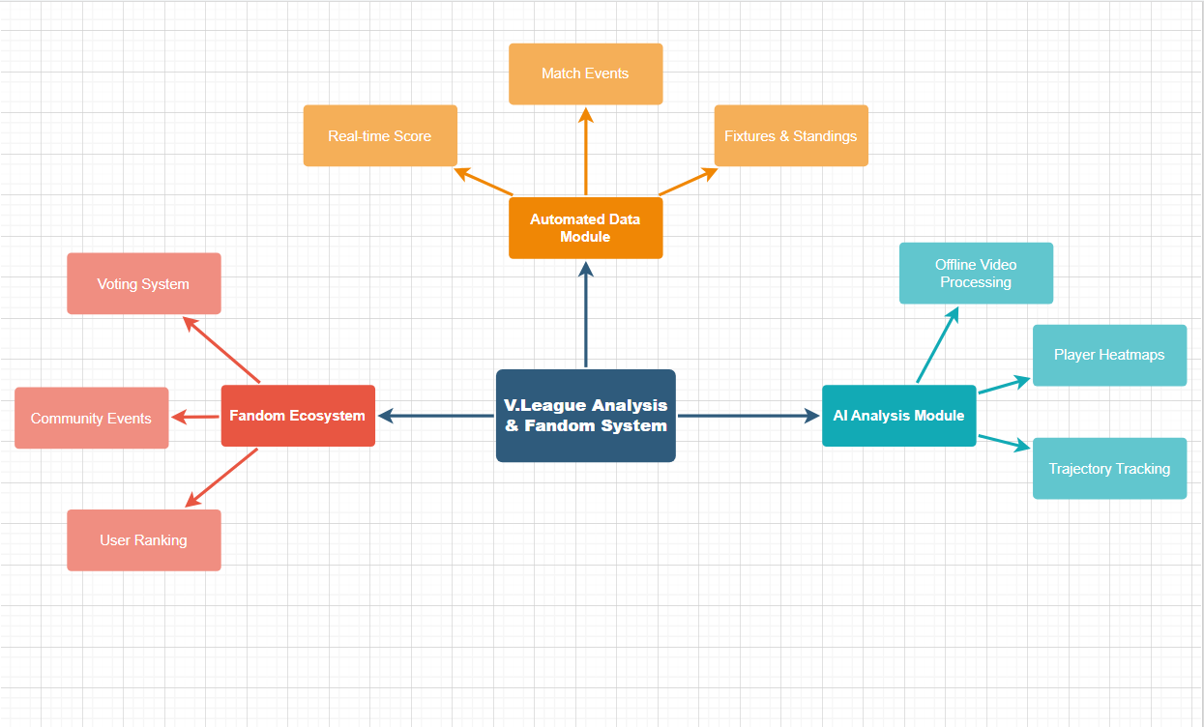
>>

6.2 Limitations & Exclusions
[Identify any product features or characteristics that a stakeholder might anticipate, but which are not planned to be included in the new product.]
<<
LI-01: No Real-time AI Processing The AI Analysis module operates in Offline mode only. The system does not support real-time computer vision processing of live broadcast streams due to hardware latency constraints. Analysis is performed on recorded video files uploaded after the match.
LI-02: Limited League Coverage The system strictly focuses on the professional Vietnamese football ecosystem (V.League 1, V.League 2, and National Cup). International leagues (e.g., Premier League, Champions League) or amateur tournaments are out of scope.
LI-03: No Betting or Gambling Features To comply with ethical standards and academic regulations, the system strictly prohibits any form of monetary betting, gambling, or odd-making functionalities.
LI-04: Third-Party Data Dependency Real-time match events (goals, whistle time) depend on the availability and uptime of the chosen External API provider. In case of API failure, the system falls back to manual data entry by administrators.
LI-05: No Ticket Sales or E-commerce The system focuses solely on performance analysis and community engagement. Commercial features such as selling match tickets or team merchandise are not included in this release.
>>

